APEX PROJECT I — PROGRESS REPORT
One-Hour-Ahead Forecasting of Metro Interstate Traffic Volume
N4: Regression-Based Time-Series Forecasting
M.Sc. Data Science and Artificial Intelligence | BITS Pilani Digital
D H Sai Nagendra | Student ID: 2025EM1300051
Report date: 31 October 2026

Abstract
This progress report presents the data preparation, exploratory analysis, feature engineering and initial forecasting results for hourly westbound traffic on the I-94 corridor. The source contains 48,204 weather-associated records but only 40,575 distinct hourly traffic timestamps. After consolidating repeated timestamps and reconstructing a complete hourly timeline, 11,976 of 52,551 expected hours (22.79%) have no traffic observation. Eight interpretable calendar and historical-traffic features produced 28,040 complete supervised examples. A chronological 70%/15%/15% split was used to train and validate a scaled Ridge Regression model against a previous-hour naive baseline. On the validation period, Ridge achieved MAE 344.655 vehicles/hour, RMSE 514.056 and R² 0.932, improving MAE by 41.81% relative to the baseline. Independent test evaluation and additional baseline comparisons remain future work.

1. Introduction and Project Objective
Traffic demand changes with time of day, day of week and recent traffic conditions. The project investigates whether historical hourly traffic counts and calendar information can support accurate one-hour-ahead forecasts of westbound I-94 vehicle volume. The target is the number of vehicles observed during hour t; the forecast is issued after hour t−1, assuming that the preceding hour’s count is available.
The progress checkpoint focuses on building a transparent, reproducible forecasting workflow: source audit, hourly consolidation, missingness analysis, exploratory patterns, leakage-safe features, a simple benchmark and an initial machine learning model.

2. Data Source and Preparation
The study uses the UCI Metro Interstate Traffic Volume dataset, supplied as an Excel workbook with nine original fields: holiday, temperature, one-hour rainfall, one-hour snowfall, cloud cover, main weather category, weather description, timestamp and traffic volume. Records cover October 2012 through September 2018.
Data-quality measure | Notebook result
Source rows | 48,204
Distinct hourly timestamps | 40,575
Exact duplicate source rows | 17
Extra repeated-timestamp rows | 7,629
Hours with conflicting target counts | 0
Zero-Kelvin temperature entries | 10
Rainfall entries above 100 mm/hour | 1
Expected hours on complete timeline | 52,551
Missing hourly traffic targets | 11,976 (22.79%)
Completely missing calendar days | 330
Exact duplicate records were removed. Repeated timestamps were consolidated to one target per hour using the median traffic count; no disagreements among target values were found. Numerical weather observations were averaged after screening implausible or invalid values, and the most frequent weather and holiday labels were retained. A continuous hourly timestamp index was then constructed. Missing traffic values were kept as missing rather than interpreted as zero traffic.
The weather screens included temperature at or below 0 K, negative rainfall or snowfall, rainfall exceeding 100 mm/hour for exploratory plausibility review, and cloud cover outside 0–100%. These screens did not alter the corresponding traffic targets. Weather information was explored descriptively but was not used as a same-hour measured predictor in the initial model.

3. Exploratory Data Analysis

3.1 Temporal data coverage
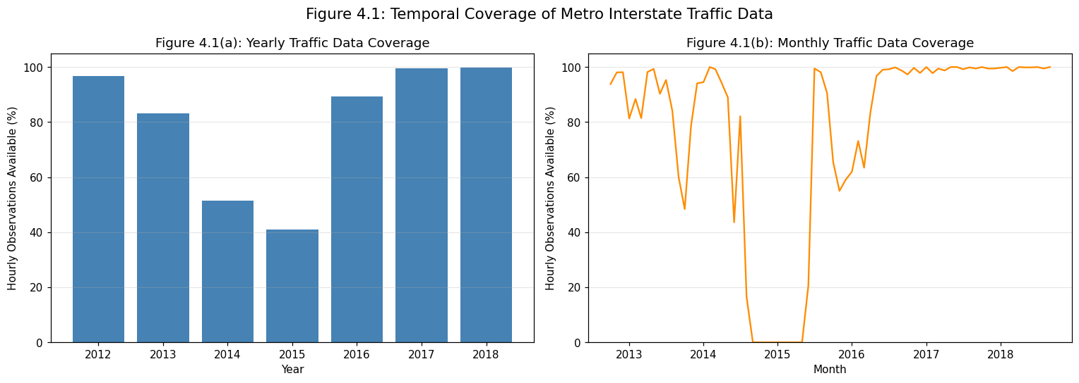
Figure 4.1. Yearly and monthly availability of expected hourly traffic observations.
Coverage varied substantially across years: 96.69% in the observed portion of 2012, 83.26% in 2013, 51.38% in 2014, 41.02% in 2015, 89.23% in 2016, 99.46% in 2017 and 99.71% in the observed portion of 2018. The monthly plot identifies an extended interval of very low or zero coverage around late 2014–2015. These gaps matter because lag-based predictors require observations at specific earlier hours. Partial first and last calendar years were evaluated only over the available study window.

3.2 Traffic distribution and recurring patterns
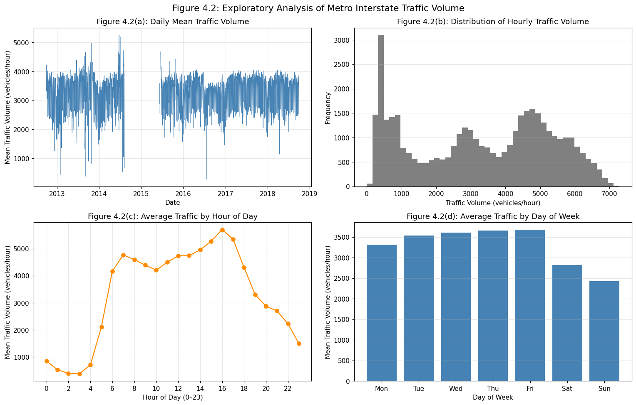
Figure 4.2. Daily mean traffic, hourly traffic distribution, average volume by clock hour and average volume by weekday.
Daily mean traffic fluctuates substantially and preserves visible gaps during periods without records. The hourly distribution is multimodal rather than concentrated around one central level. Average demand reaches a maximum of 5,708.61 vehicles/hour at 16:00 and a minimum of 373.21 at 03:00. A second, smaller morning peak occurs around 07:00 (4,769.83 vehicles/hour). Friday has the highest weekday mean (3,674.78 vehicles/hour), while Sunday is lowest (2,426.25). These patterns motivate hour, weekday, weekend and historical-lag features.

3.3 Combined hour-of-week patterns
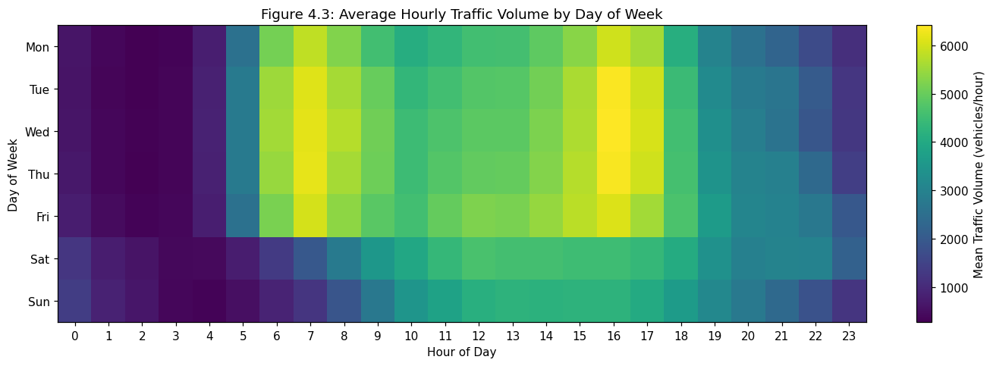
Figure 4.3. Mean traffic volume for each combination of weekday and hour of day.
The heatmap shows sharp morning and afternoon peaks on weekdays, whereas weekend demand rises more gradually. The largest cell mean is 6,414.26 vehicles/hour on Wednesday at 16:00. Wednesday at 07:00 averages 6,171.80 vehicles/hour, compared with 1,233.06 on Sunday at the same hour. The contrast indicates that the effect of clock hour depends on weekday; it supports investigating daily and weekly lag features, although predictive value must be tested rather than inferred from EDA alone.

3.4 Holiday-labelled observations
Group | Mean (vehicles/hour) | Median | Observed hours
Non-holiday label | 3,293.82 | 3,433 | 40,522
Holiday label | 863.96 | 812 | 53
Holiday-labelled observations have a much lower average than non-holiday-labelled observations, but the comparison is strongly imbalanced. The source holiday field labels particular timestamps, not necessarily every hour of each holiday date. Therefore, these descriptive averages must not be interpreted as the effect of entire holiday days. No holiday feature was included in the initial forecasting model.

4. Feature Engineering and Forecast Protocol
For a target at hour t, only traffic counts observed through t−1 and calendar variables known in advance are eligible as inputs. The complete hourly index is retained when shifting values, so lag offsets correspond to real elapsed hours rather than the previous available row. The 24-hour rolling mean uses a series shifted by one hour; the target hour itself is never included.
Feature | Definition / purpose
hour | Clock hour of target (0–23)
day_of_week | Weekday of target (Monday=0)
month | Calendar month of target (1–12)
is_weekend | 1 for Saturday/Sunday, otherwise 0
lag_1 | Traffic count one hour before target
lag_24 | Traffic count 24 hours before target
lag_168 | Traffic count 168 hours before target
rolling_mean_24 | Mean traffic across the 24 preceding hours
Rows with missing targets or any of the eight required features were excluded. This left 28,040 supervised examples from 40,575 observed target hours. No same-hour observed weather variable was included. Raw hour, weekday and month were retained for simplicity, although their cyclic structure is not explicitly represented in the linear model.

5. Initial Model Development and Validation

5.1 Chronological evaluation design
The 28,040 eligible examples were sorted by time and divided by row position: 19,628 training observations (70%), 4,206 validation observations (15%) and 4,206 reserved test observations (15%). Training spans 12 October 2012–24 September 2017; validation spans 24 September 2017–4 April 2018; the reserved test period spans 4 April–30 September 2018. No random shuffling was applied.

5.2 Baseline and Ridge Regression
The naive benchmark predicts the target hour’s traffic as equal to the preceding hour’s observed traffic (lag_1). Ridge Regression was trained with eight engineered features. StandardScaler and Ridge(alpha=100) were combined in a scikit-learn pipeline, ensuring that scaling parameters were learned from training data only. Alpha=100 is an initial setting; it has not yet been selected through a systematic validation search.

5.3 Validation results
Model | MAE (vehicles/hour) | RMSE (vehicles/hour) | R²
Previous-hour naive baseline | 592.286 | 820.215 | 0.827
Ridge Regression | 344.655 | 514.056 | 0.932
Ridge reduced validation MAE by 41.81% and RMSE by 37.33% relative to the previous-hour baseline; R² increased from 0.827 to 0.932. These values describe validation performance only and do not establish final generalization to the reserved test period.
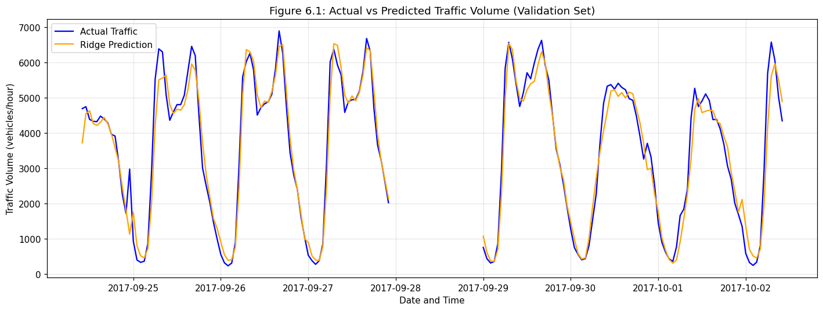
Figure 6.1. Actual and Ridge-predicted hourly traffic in the first 168 eligible validation observations; missing hours are shown as gaps.
The prediction curve follows major daily rises and falls, including low-demand overnight periods and many high-demand peaks. Deviations remain during rapid changes and at some peaks. The plot is a short illustration of behavior; the metrics above were calculated over all 4,206 validation observations.

6. Interpretation, Limitations and Progress
The initial results indicate that combining historical traffic and calendar inputs is more informative than simply carrying the preceding hour forward. However, the current comparison uses only a previous-hour naive baseline; a 24-hour seasonal naive benchmark is especially relevant given the strong daily patterns found in EDA. The linear model may not fully capture nonlinear or interacting effects, and missing historical records reduce the number of usable examples.
Other limitations include exclusion of weather forecasts, incidents and events; a small and timestamp-specific holiday-labelled sample; and use of raw numerical calendar variables rather than cyclic or categorical encodings. The present report does not claim a causal effect of weather or holidays, nor does it report test-set accuracy.

7. Next Steps Before Final Submission
The next phase will compare the existing Ridge model with a daily seasonal naive baseline (lag_24), review the choice of Ridge regularization using validation data, and inspect residual errors across peak and off-peak periods. After selecting the approach, the final model will be trained on the combined training and validation periods and evaluated once on the held-out test set. Additional checks will include reproducibility from a clean kernel, verification of output figure files and consistent reporting of all model metrics.

8. Conclusion
At this checkpoint, the project has completed a detailed source-quality audit, hourly reconstruction, exploratory analysis, leakage-aware feature engineering and an initial model comparison. Strong hourly and weekly traffic patterns were observed. Ridge Regression achieved validation MAE 344.655 vehicles/hour, RMSE 514.056 and R² 0.932, outperforming the previous-hour baseline. The work establishes a reproducible starting point for more rigorous baseline comparison and final out-of-sample evaluation.

References
UCI Machine Learning Repository. Metro Interstate Traffic Volume dataset. Dataset description and original data source.

